HERSTMONCEUX AND WARTLING

PARISH NEWS
October 2021 50p
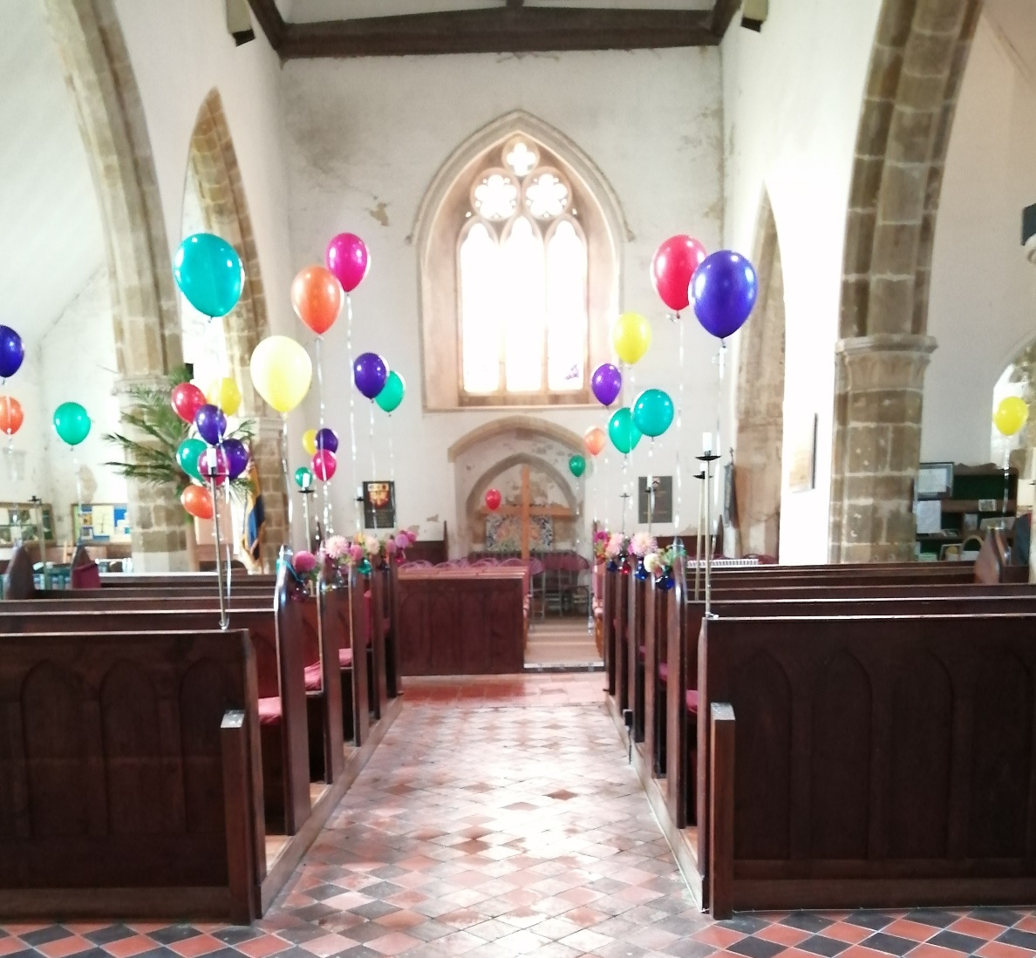

This Month

Rev Richard writes the letter from the Rectory; Rev Peter’s Green Page; Melinda’s Famous Hymns column covers " O Love that will not Let Me Go ", plus the regular columns and news from around the parishes

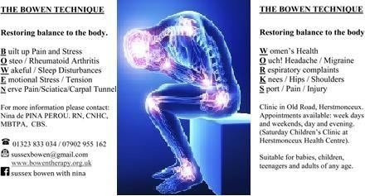

From the Rectory

Dear Parishioners,

During this month we should think about the world Harvest. It is the time to celebrate all that has been produced throughout the past year culmination hopefully in a wonderful Harvest.

The Old English word Haerfest was their word for autumn. We can see that it refers primarily to the season for reaping and gathering grain and other produce.

The full moon nearest the Autumn Equinox is called the Harvest Moon. Harvest Festivals are traditionally held on or near the Sunday of the Harvest Moon. It can appear in late September or early October. This year’s Harvest Moon will appeared on Tuesday September 21st night before the Equinox this year. This full moon is linked to the Harvest because it comes around the time of the end of the Harvest season always rising around sunset, giving its helpful light to aid the workers in the fields to complete their in gathering.

A very ancient Harvest Festival is still celebrated in some Churches at the beginning of the Harvest season on 1 August. It is called Lammas, meaning 'Loaf Mass'. Farmers would make loaves of bread from the first grain of the fresh wheat crop. These were given to the local church as the Communion bread during a special service thanking God that the harvest had arrived. This is similar to the ancient Jewish Feast of Pentecost or First Fruits.

The modern British tradition of celebrating Harvest Festival in churches began in 1843, when the Reverend Robert Hawker invited parishioners to a special thanksgiving service at his parish church at Morwenstow in Cornwall. Victorian hymns such as "We plough the fields and scatter", "Come ye thankful people come" and "All things bright and beautiful" helped popularise afresh the idea of remembering the importance of harvest and spread the annual custom of decorating churches with home-grown produce for the Harvest Festival service. Harvest festival has links with the ancient Jewish feast of Tabernacles or Ingathering. We are Having a Harvest Service at St Mary Magdalene Church Wartling on September 26th at 10am and At All Saints Herstmonceux on October 3rd at 10am. Please come and join the celebrations. Our collections at these services are always given away to charities helping those in need.

Fortunately we are promised in the Bible that whatever else may happen there will always be a Harvest. "While the earth remains, seed time and harvest, and cold and heat, and summer and winter, and day and night shall not cease.”(Gen 8v22) So we do not need to worry about this at least. With God’s help we will continue to produce enough food to feed the world and hopefully we will find the will to distribute it fairly. Do you remember this famous quote regarding this “We have the ability, as members of the human race, we have the means, we have the capacity to eliminate hunger from the face of the earth in our lifetime. We need only the will”.
(J F Kennedy 1963)

The current world population of 7.8 billion is expected to reach 8.6 billion in 2030, 9.8 billion in 2050 and 11.2 billion in 2100. In 2014 the world produced 17% more food per person than it did 30 years previously, and the rate of food production has increased faster than the rate of population growth for the past two decades. However, recent calls from the Food and Agriculture Organisation (FAO) suggest this might be changing, with estimates that 60% more food is required if population numbers increase to nine billion by 2050. Of course the Covid pandemic and recent climate change events may well be hampering our world harvest to keep increasing at this time.

For the Christian, Harvest also has a deeper significance, we are promised in the Bible that with God’s help we can each be His good crop rather than independent weeds that are of no use to him. By following the Lord Jesus we ourselves will one day be a part of God’s great in gathering or harvest on the last day of human history. As a result of being his crop we can also each produce a harvest of good deeds that we are promised in the Bible will have a truly lasting effect.

May you all be able to celebrate a bountiful Harvest in and around you during this wonderful season.

Richard Steven

Prayer for October

A Harvest Prayer

Creator God, forgive our moments of ingratitude,
the spiritual blindness that prevents us
from appreciating the wonder that is this world,
the endless cycle of nature,
of life and death and rebirth.
Forgive us for taking without giving
reaping without sowing.
Open our eyes to see
our lips to praise
our hands to share
May our feet tread lightly on the path we tread.
and our footsteps be worthy of following
for they lead to you.
Amen

Parish Walks

Our next parish walk is on 9th October meeting at Wartling Church 2pm finishing at 4pm. David Harding is leading the walk around Wartling and his farm.

Ring Richard Steven 01323 833124 for more details or just come along.

October Services in Herstmonceux and Wartling Parish Churches

3rd October Herstmonceux Harvest.
8am Wartling Holy Communion (BCP)
Hebrews 1:1-4, 2:5-12. Mark 10:2-16.
10am Herstmonceux Harvest Service
1 Timothy 6:6-10. Matthews 6:25-33.

10th October 19th Sunday after Trinity.
8am Herstmonceux Holy Communion (BCP)
Hebrews 4:12-end Mark 10:17-31.
10am Wartling Holy Communion (CW)
Job 23:1-9, 16-end. Hebrews 4:12-end
Mark 10:17-31.
6pm Herstmonceux Evensong.
Psalm 127. Joshua 5:13, 6:20.
Matthew 11:20-31.

17th October 20th Sunday after Trinity
8am Wartling Holy Communion (BCP)
Hebrews 5:1-10. Mark 10:35-45.
10am Herstmonceux Holy Communion (CW)
Job 38:1-7. Hebrews 5:1-10. Mark 10:35-45.

24th October Last Sunday after Trinity
8am Herstmonceux Holy Communion (BCP)
Hebrews 7:23-end. Mark 10:46-end.
10am Wartling Morning Prayer (CW)
Psalm 119:89-104. Isaiah 59:9-20.
Luke 14:1-14.
11.15am Herstmonceux
Children’s Activity Morning.
6pm Herstmonceux Celtic Service
John 5:36b-end.

31st October All Saints.
8am Wartling Holy Communion (BCP)
Revelation 21:1-6a. John 11:32-44.
10am Herstmonceux Celtic Healing Service
With Holy Communion
Isaiah 25:6-9. Revelation 21:1-6a
John 11: 32-44.

7th November 3rd Sunday before Advent
8am Wartling Holy Communion (BCP)
Hebrews 9:24-end. Mark 1:14-20.
10am Herstmonceux Family Service.

Rev Peter’s Green Page Focuses Kindness out of a Crisis

As we are all only too aware we are not fully out of the pandemic yet. But the one thing we have learned when it was at its peak, was that our guardian angels actually lived, in many cases, next door to us or just down the street.

As has been learned over many years and in many instances, mutual aid and solidarity become most visible in a period of crisis. This is when we have a glimpse of the type of society that we could be. To many, it was as if the pandemic took place in some kind of an alternative reality, but this was not the case. We were not living in a society that could be, this was the society do we do live in and the society that is.

These instances of mutual aid that sprang up overnight, run by friends, neighbours and Parish Councils were never established by Central Government, they didn’t need to be as it turned out that they were there already. We learned through the lessons of the time just who we really were, and we were certainly not the people that advertising and the mainstream media seemed to assume or tell us who we were.

The Covid 19 Crisis gave us a far more optimistic view of people. Irrespective of politics or cultural differences many people were out and about, organising, distributing and helping their neighbours. There were of course some instances of those taking advantage of the situation, but these were rare indeed, and we learned that we are only as strong as the weakest among us.

How we fully emerge from this time in history will actually, shape the future, the future for us, for our children, and for our grandchildren. We have lived through a time when we are in the position to shape our futures. Survival, our survival, depends on mutual care and compassion and, as the pandemic has taught us, in our world, it is not so much as the ‘Survival of the Fittest,’ but more the ‘Survival of the Kindest.’

The question is now then, where do we go from here? Do we take the opportunity to nurture and develop the relationships and networks that came to prominence, or do we slip back into the old ways, and watch what became to be when the chips were down, start to vanish like the supermarket doorstep deliveries? The choice really is ours.

English Country Dancing

Bodle Street Hall, Wednesday evenings 8:00pm to 10:00pm.

We welcome new members. No need to bring a partner.

Friendly club, where we help any inexperienced dancers to learn.

Phone June: 07908353968.

PARISH NEWS
Please send text copy email (together with your name and phone number) to Miss Katherine Blake, theparishnews@hotmail.com (c/o Parish News). Deadline is midday on the 15th of the month prior to publication.
N.B. due to new arrangements no copy can be accepted later.

PARISH NEWS SUBSCRIPTIONS
If you would like a copy of the Parish News delivered to your door each month for the discounted rate of £5:50 for the year, then please contact Chris Edwards on 01323 833207 or email hwparishnews_subscriptions@hotmail.com
WILL WRITING SERVICE
Usual fee per Will £145 plus VAT Free Wills Brochure Available on Request (Lasting Powers of Attorney from £235 + VAT)
Tel: (01323) 460395
Barry & Co Solicitors
Bay Terrace Pevensey Bay, East Sussex, BN24 6EE

God is Still the Point at the Centre – Written by Fiona Bower

This phrase written by Julian of Norwich a fourteenth century anchoress is one upon which I have pondered on for many years. I read once that at the very centre of our being there is a point that is the pure Glory of God and that part of us belongs entirely to him. This thought brings me great comfort and joy.

Sitting in my chair I often have more opportunity than most to be still. It is easy for me to be in my own space as I have the privilege to see the world from a different perspective. Our world can be chaotic and noisy and it can sometimes be difficult just to find the space in which to be still.

One of my interests in life involves trains and I attend regular meetings in London regarding accessibility. Whenever I travel to our capital, I notice that everyone is trying to stay in their own little world-their own bubble, wearing headphones and often masks. They are all avoiding eye contact with one another just trying to keep in their own space and trying their best not to engage with anyone else. As I power across London Bridge dodging people walking in all directions I often long to be in a place of serenity and calm where I can find God.

A couple of years ago Mr Wiz, my trusty canine partner and I sat at a pavement café in the city of London in front of a church very close to the Walkie Talkie building enjoying a most welcome cup of coffee. I struck up a conversation with a man seated at the next table who turned out to be the administrator at the church, St Margaret Pattens. The church was founded in 1067 burnt down in the Great fire of London and rebuilt by Wren in 1686. It stands in the city surrounded by newer buildings. I must have passed by the church dozens of times and never registered its presence. The man whose name was Christopher invited me to visit the church to experience tranquility.

Once inside I could hear nothing of the noise outside. All was calm and still. In the pews were sitting several people in silence. Some had their eyes closed but they were all still. It gave me great hope and served to remind me that even in the busiest places we can find places to be still and silent so that we can really listen to what God is saying to us. He is always there with us at the very centre of our being.

Some lines to make you smile
- If you can smile when things go wrong, you probably have someone in mind to blame.
- The easiest way to find something lost around the house is to buy a replacement.
- When dog food is new and improved tasting, who tests it?
- If I agreed with you, we’d both be wrong.
- War does not determine who is right – only who is left.
- They begin the evening news with ‘Good Evening,’ then proceed to tell you why it isn’t.

P. Thompson
Carpentry Services
25 years of experience

Door Hanging - Skirting & Architrave
Wood & Laminate Flooring - Flat Pack Furniture Assembly

Contact Peter on 07368451716 peterthompson24@icloud.com

Famous Hymns

O Love that will not Let Me Go - George Matheson (1842 – 1906) with thanks to David Fielding – Pastor Castlefields Church Derby, and Dr Hawn, umcdiscipleship.org

George Matheson recalled this hymn “was composed in the manse of Innellan on 6th June, 1882… Something happened to me, which was known only to myself, and which caused me the most severe mental suffering.”

Matheson apparently graduated from Glasgow with 1st class honours aged 19, but at a time of deep tragedy – he was rapidly going completely incurably blind. He’d fallen in love with a female student and they planned to marry. He broke the news of his impending blindness, and asked if she’d still marry him? She replied “I don’t want to be the wife of a blind man” – and they parted.

He never married. Through these deep trials, he came to place all his trust and hope in the love of God through Jesus Christ his Saviour. Despite blindness, he resolved to study Theology / Christian History and go into ministry. His sister learned Greek, Latin and Hebrew to help his studies. She also helped with his pastoral responsibilities. His ministry began in 1868 at Innellan (Argyllshire). Not only did he preach, but he wrote popular books on spiritual matters. Queen Victoria invited him to preach at Balmoral, and had one of his sermons, on the Book of Job, published.

Many writers report struggling to compose a hymn text, revising and tweaking until the metre and imagery are exactly right. The painful memory of that girl’s rebuff flooded back to Matheson on the evening of his sister’s wedding: he told how on that occasion he penned his most famous hymn.

“[It] was the fruit of that suffering. It was the quickest bit of work I ever did in my life. I had the impression rather of having it dictated to me by some inward voice than of working it out myself. I am quite sure that the whole work was completed in five minutes, and equally sure it never received at my hands any retouching or correction. I have no natural gift of rhythm. All the other verses I have ever written are manufactured articles; this came like a dayspring from on high. I have never been able to gain once more the same fervor in verse.”

Each stanza begins with a key word—Love, Light, Joy and Cross. Love is a haven for a “weary soul” and as deep as the “ocean.” Light illuminates the way: our “flickering torch” is augmented by the “sunshine’s blaze” of Christ, Light of the world. Joy seeks for us “through pain.” The last verse indicates that through Christ’s suffering, “blossoms red” are formed (out of self-sacrifice) that lead to new life.

Albert Peace (1844-1912), a renowned Scottish organist, wrote the tune St. Margaret at the request of the Scottish Hymnal Committee. Peace said the tune came to him as quickly as the text had come to Matheson: “After reading it over carefully, I wrote the music straight off, and may say that the ink of the first note was hardly dry when I had finished the tune.” Melinda Stone

A Thought From Rev Peter

The Bible has sections in it about diseases and health issues, and this is such from Leviticus 13: verses 45-46.

“Anyone with such a defiling disease must wear torn clothes, let their hair be unkempt, cover the lower part of their face and cry out, ‘Unclean! Unclean!’ As long as they have the disease they remain unclean. They must live alone; they must live outside the camp.”

For the period of lockdown my jeans and T shirts certainly became ragged as I worked outside and carried out DIY jobs. Indeed I did cover the lower part of my face with a mask whenever I went out and yes, my hair certainly became very long as the hairdresser was closed for that period. I didn’t have Covid, but I am aware that those that did instructed others to stay away, which may well qualify as crying out “unclean.”

However, the instructions to “live alone” and the “outside the camp” does sound rather like social distancing though.

VINEHALL INTERNATIONAL CLASSICAL CONCERT SERIES
33rd SEASON 2021-22

INGRID FLITER (Piano)
Saturday 2nd October 2021 at 7.30 p.m.

Programme

Beethoven Sonata op.31 n.3 in E flat
Beethoven Sonata op.31 n.2 in D minor
Schumann Symphonic Etudes op. 13

For full details/free mailing/tickets phone 01580 883092 or write to A.G. Whitehead, Vinehall School, Robertsbridge. East Sussex. TN32 5JL.
e-mail: geoffreywhitehead@vinehallschool.com

Children’s Page

This month we are thinking about the harvest. Farmers are working hard to being in the crops which will be used as our food or food for the animals. At the Harvest Festivals held in the churches we thank God for the harvest, for the food that he helps us to produce, for the sun and the rain we need to grow the crops. We thank the people who produce all our food.

At the services many people bring an item of food to make into baskets to give to anyone who is needy. A lady once said to me that she looked forward to receiving a parcel from the Harvest as it meant that people in the church were thinking of her and it made her year.

We hear of people who may like a parcel by friends and neighbours telling us about them.
In the bible there is a story about neighbours and how one helped another, even though they were not friends. You may know it, it is called The Good Samaritan.

“A man was travelling from Jerusalem to Jericho”, said Jesus, “when he was attacked by robbers. They took everything he had and left him for dead. After a while, a priest came by – but he walked past him and went on his way: he would not touch him. Then a Levite came along, he crossed over so he wouldn’t get too close as the man lay wounded on the road. The wounded man felt the hot sun beat down on him and was sure he would die, but a little later a Samaritan came along the road. Everyone knows that Israelites and Samaritans don’t speak to each other, but the Samaritan stopped to help. He bathed and bandaged the man’s wounds. Then he helped him on to his own donkey and took him to an inn where he paid for the man to be looked after till he was well.”

Jesus went on to say, “Who do you think was a good neighbour to the man who was hurt?
The man who Jesus was talking to said. “The one who was kind to him”. Jesus said “Now go and do the same to all you meet.”

Those men who passed by probably had good reasons not to stop, we will never know but we need to do better. Before the virus, we could have helped anybody who needed help by doing things for them or taken a small gift round to them but it is not wise now to do this but a very good friend once said to me “Give a smile, say Hello “ that’s the best thing you can do. Jesus wants us to be the best we can be, he doesn’t ask for perfect.
Of course, there is one BIG thing you can do for all your friends, family, and neighbours – you can pray for them and here is a little prayer you could use:-

Thank you Jesus, for making us part of your family. It is good to know that we belong to you and to each other as brothers and sisters. Please teach us to love one another however difficult it may seem and to care for others who have very little to eat and maybe nowhere to live. Help us to share all we have. Amen.
Or even just this: Thank you Jesus for everyone and for everything we have. Amen.

Why not cut out pictures of people from magazines or papers and stick them on to a sheet of paper and when you pray look at them and thank God for them, they all have families and friends just like you.

Sarahjane Prince Cert Ed, MAR. MSMA (NHS registered)
Sports Massage, Reiki, Hot Stone Massage, Aromatherapy, Swedish Massage, Zonal Face Lift, Ear Candling, Foot, Hand and Face Reflexology, Facial Cupping, Fertility and Delivery Reflexology
Clinics in Dallington and
Heathfield Tel: 07762 576495 www.eastsussexmassage.co.uk info@eastsussexmassage.co.uk
Working from the rooms of East Sussex Osteopaths
ALL ASPECTS OF AERIAL AND SATELITE WORK
TELEPHONE/BROADBAND/WIFI
FRIENDLY AND RELIABLE LOCAL ENGINEER
25 YEARS EXPERIENCE REGISTERED WITH TRADING STANDARDS AND CHECKATRADE
CALL STEVE ON 01323 442557
or 07968345409
www.hdi-aerials.co.uk

Children’s Page continued…

Hope.

I don’t normally repeat an assembly outline in the Parish News but this one has some really good messages in it and I am sure that everyone could take something from it. So here is the abridged version.

The bible says there are three important things in life, love, trust (faith) &hope. Hope is a really beautiful thing because we cannot enjoy life unless we have hope. I thought about what hope really could be and came up with: “Hope is believing that good things will happen”.

We all have hopes no matter what age you are, as a baby we hope for food and love, growing up hopes are for food (usually nice things) friends to play with, toys and again love. As adults things are not usually very different except for the means to look after our families, a nice home and again love.

Maybe you hope to be a fantastic footballer or become a popstar or drive a really fabulous car, well it may happen but maybe not in the way you thought of. When something you hope for doesn’t happen don’t be upset just think I will put my hope in God and he will help in the best way for you.

In assembly I told this story:

One night, a house caught fire and a young boy was forced to flee to the roof. The father stood on the ground below with outstretched arms, calling to his son, “Jump, I’ll catch you!” He knew that the boy had to jump to save his life.

All the boy could see, however, was flame, smoke and blackness. As you can imagine, he was afraid to leave the roof. But his father kept yelling, “Jump! Jump! I will catch you.” But the boy protested, “Daddy, I can’t see you,” his father replied “But I can see you and that’s all that matters”.

That boy hoped that his father would catch him and the father hoped that the boy would trust him enough to jump.

God can see us. Someone once said, “I don’t know what the future holds, but I know who holds the future” God holds each of our futures and so we can put our hope in him.
This is a very grownup thought so ask an adult to explain if you don’t understand.

Prayer:
Help us to have true hopes and help us to hope in you. Amen.

MICHAEL SALVAGE
TREE SURGEON
All Aspects of Tree Surgery and Felling. Also, Stump Grinding and Fencing
Fully qualified with over 40 years experience
£10 million public liability insurance.
Tel: 01323 442121
PARISH NEWS SUBSCRIPTIONS
If you would like a copy of the Parish News delivered to your door each month for the discounted rate of £5:50 for the year, then please contact Chris Edwards on 01323 833207 or email hwparishnews_subscriptions@hotmail.com

Vitality Villages

Vitality Villages Men’s Shed / Community Workshop Open-Day 13 October 2021

The Herstmonceux Men’s Shed is in a workshop at Herstmonceux Castle and open on Wednesdays from 10.00 am until 4.30pm. To reflect wider interest in the project the morning session from 10am - 1.00pm, is a Community Workshop which men and women may attend whilst the afternoon retains the original Men’s Shed title.

On Wednesday October 13th we will have an open-day for anyone to pop-in and see what we do without any commitment.

At the “Shed” you can bring projects, join in one of our community repair projects or just have a cup of tea and pick up hints and tips. In addition to the workbenches for hand and power tools we have an area with tables and chairs for planning or working on projects and craftwork. You do not have to be expert in a craft, and we encourage members to share their skills with others.

Workspaces are 2 metres apart and facemasks are optional for closer working. We have vacancies for both sessions. If you would like to see what we do or want more information, please call me so we spread visits to keep our safe-working rules and book your access via the castle grounds.

Alan McInnes 01323 833306

National Garden Scheme

The National Garden Scheme (NGS) is a charity which opens gardens and sends the money raised to nursing and caring charities, including Macmillan Cancer Support, Marie Curie, Hospice UK, Carers Trust, Parkinson`s UK, Maggie`s Cancer Centres, ABF The Soldiers Charity and Perennial (who help disabled gardeners)

I would like to thank all the visitors and helpers at Butlers Farmhouse for helping us raise the amazing sum of £2441 this year during our NGS openings and private visits. Teas were provided by Family Support Work (FSW) who are a diocesan based Sussex charity who help needy families and they raised £1389 at Butlers.
The NGS Herstmonceux Parish Trail raised another £676 and Herstmonceux Castle are also terrific supporters of the NGS whose donation is still to be finalised.
Thank you for all your terrific support- look out for the little yellow booklets from February onwards, and our next opening at Butlers Farmhouse at the end of March 2022.

Irene

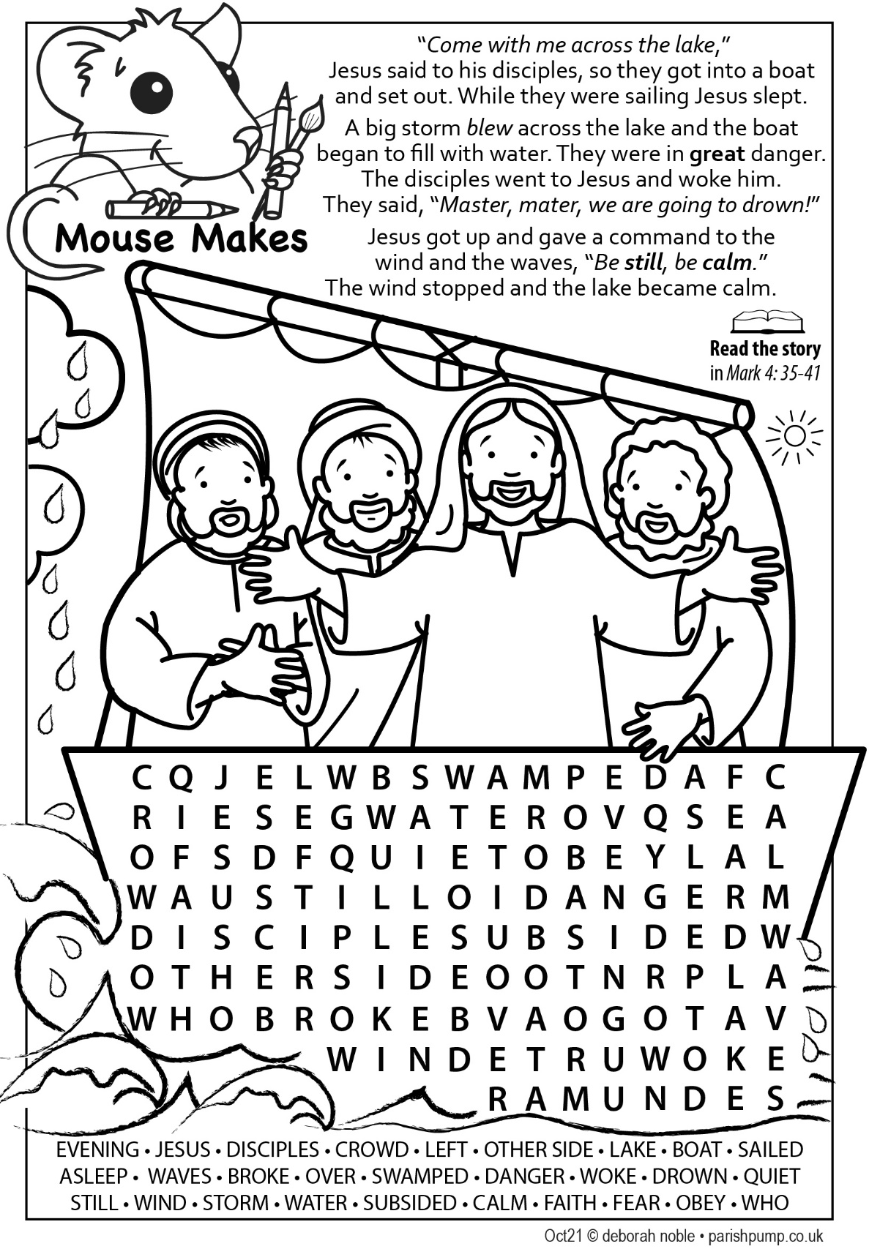

Weather in August – Disappointment Continued

Few of us will remember the summer of 2021 in our part of East Sussex as being memorable for its weather. Cool and dull are the words which perhaps best sum things up. For the first three weeks of the month our weather and winds came off the Atlantic; not too hot nor too cold, not particularly sunny and some decent amounts of rain to satisfy gardeners and to dismay farmers gathering in the harvest and holidaymakers too. We had nearly an inch of rain overnight on the 8th/9th and just over two inches in total.

The last week of the month was dominated by cool northerly winds laden with layers of grey cloud giving us days of Stygian gloom more reminiscent of November than August.

The coolest day of the month was 17º on 17th August and the warmest a mere 23ºC on the 22nd. Overnight temperatures held up well so the mean temperature for the month was not as low as it otherwise might have been but over a degree less than July and only just above that for June. August 2020 was a rather different kettle of fish with the average maximum temperature well over 3ºC higher and 9 days warmer than the top maximum temperature in August 2021. Readers may recall the 6 days with the maximum temperature above 30ºC including one day with a scorching 34ºC.

Fortunately or unfortunately depending on your view, the really hot weather remained in Southern Europe where at times it became dangerously hot with threats to health and widespread wildfires. It would have drifted our way if our winds had come from between south and east but, for lovers of sun and warmth, August’s weather was a case of winds from the wrong quarter.

It will be interesting to see whether September will prove to be warmer than August.
Tim Roberts

The Ray and Sheldon Club

The Ray and Sheldon over 60's Social Club was started and has been running since the 1950's. It was set up by two Community Nurses for older people who may feel isolated and lonely

It runs on the 2nd and 4th Friday of every month from 2.00 pm to 4.00 p.m. in the Herstmonceux Big Village Hall, £3.00 per visit and an Annual Membership of £6.00. There is plenty of free parking right outside.

Members enjoy a chinwag, quizzes, speakers, singers, beetle drives, and more. Meetings include a cuppa and biscuits. It is very friendly and welcomes new members.

Any further information please contact Anne 441244. We meet again on Friday 8th October 2021.

A warm welcome awaits you.

Village Information Centre

Opening Hours
We are open five days a week - Monday to Friday - between 10.00 am and 12.00 noon.
If you would like to become a volunteer at the VIC please do contact me - Sheila Charlton - on 01323 833673 when I should be pleased to hear from you.
Hearing Resources
Sessions will be held on Friday 1st October 2021 and Friday 22nd October 2021 between 10.00 am and 11.45 am when we are able to offer maintenance of most types of hearing aids and replacement batteries. Please remember to bring your book.

Windmill Hill Horticultural Society

Since last month, members enjoyed a visit to Butlers Farmhouse. The garden has many different areas and there was still plenty of colour. After admiring the garden we were treated to tea and some particularly scrummy cake.

Thursday 7th October will see our first meeting for such a long time, and we are all looking forward to it. We meet in the Reid Hall, Boreham Street where doors will open at 7pm for a 7.30pm start. The Reid Hall is spacious, with opportunity for opening doors and ensuring good air circulation. The subject for the evening is 'Gardening for Wildlife- how can our gardens help?' We have a variety of things planned including something for you to take away, and we would love to welcome new members.

Please get in touch if you would like to know more about WHHS activities.

Penny Vasey – p.vasey@btinternet.com

Herstmonceux Children’s Sunday Activity Morning

We are re-starting our Children’s group meeting on Sunday Mornings at Herstmonceux Church. The first one is on October 24th at 11.15am until 12.15am. All ages welcome. Pre-schoolers with adult. Over 11’s to help with younger.

For more information please ring Richard 833124 or Pam 833079

Shoebox Appeal

We are again supporting the Mustard Seed Mission to supply filled shoeboxes for children in Eastern Europe. We sent over 50 last year and these were very gratefully received. Can we do better this year?

Shoeboxes must be in by the middle of November. For full details, leaflets are available in both churches and with me, or give me a ring on 01323 833079.

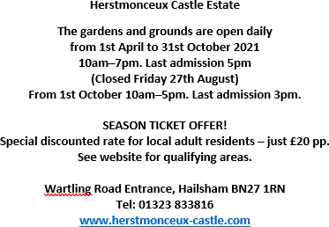
Would you like your business to reach more of the Herstmonceux and Wartling community?  Advertising in the Herstmonceux and Wartling Parish News for the year (12 editions) ranges from £40 to £125 depending on the size of the advert.  Contact Sarah Honeysett, via email on hwparishnews@outlook.com | S R WELFARE LTD  FOR ALL YOUR ELECTRICAL NEEDS INSURED AND CERTIFIED  CALL SEAN  07904330146
SARAH BARTHOLOMEW  RHS Qualified and fully equipped gardening service. For the service and quality you have been looking for.  Lawns, Hedges, Trees, Shrubs  The way you want them  Flower Beds, Pots, Troughs, Baskets Weeded, planted and made beautiful again ALL this and more.  01323 847338 home or mobile 07780 681878  For a prompt reliable and professional service | Bit of this, Bit of that.  Property and garden maintenance and improvements General handy man  Derek Willis Email: bitotbitot@aol.com  07977 196304 or 01323 833304

Pat’s Flowers  For all your Wedding Flowers and Funeral Tributes  2 Amberstone Cottages, Amberstone, Hailsham, East Sussex, BN27 1PG  Call Pat on 01323 848217 or 441853  patsflowers1@outlook.com | TAI CHI & QIGONG  For current class information  Please contact  Tel: 07752 012438  Email: LynneNwood@aol.com
ATTWOOD MOTOR SERVICES
SERVICING . REPAIRS . TYRES EXHAUSTS . MOT’S . CAR COLLECTION
Ring Billy 07801563009 or01323 833893
ALLCREDIT CARDSACCEPTED
billinghurst.b@yahoo.com
CORDLESS LTD  Carpentry & All Building WORK  www.cordlessltd.co.uk  01323 832942 or 07957201565 | FLOWERS GREEN PLANTS  ChurchRoad, Herstmonceux 01323  833256  www.flowersgreen.co.uk  For all your bedding plant requirements.  Alsoherbs, perennials, alpines, patioand basket plants, vegplants, hangingbaskets and patiopots.  RETAIL & WHOLESALE  Open 9am to 4pm Mon-Fri & Sat 9am to 1pm.  Sundays - Closed
RICHARD WHALE  DOMESTIC APPLIANCE REPAIRS  Microwaves – Vacuum Cleaners Dish Washers – Electric Cookers TumbleDryers –WashingMachines  COMPETITIVE PRICES  TEL: 01323 507043  24 HOUR ANSWERING SERVICE | CHRISTOPHER REED  Interior & Exterior DECORATING  PROFFESSIONAL WORK ALL ASPECTS, FULLY INSURED  FREE ESTIMATES  PLEASE CALL 01323 833179

THOMPSON & CO - Builders
Family run business in Herstmonceux for 45 years
Extensions Drives Re-pointing
Re-roofing Alterations Patios
and all General building
Tel: 01435 865009 - Mob: 07704723216 - 01323 832304
e-mail: thompsonco@talktalk.net
Kate Short Complementary Therapies
Soothing, Effective Treatments in a Tranquil & Restorative Setting.
Ibelieve that ‘time out’, relaxation & massage are the gateway to improved health & well-being Anyone undergoing times of stress or change or who simply wants to relax, settle their mind, improve sleep patterns or boost their immune system, could find benefits in:
Reflexology, Seated Head-Neck-Shoulder Massage or Reiki Healing
and you’ll be back on your feet in no time!
Contact me to find out more or to try a free 10-minute taster session.
Kate Short, Conquerors, Stunts Green, BN27 4PR 01323 832446
– kate@inkyspot.plus.com
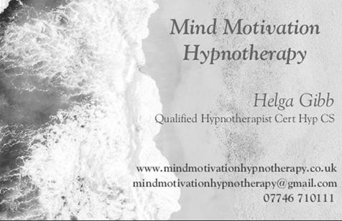 | Would you like your business to reach more of the Herstmonceux and Wartling community?  Advertising in the Herstmonceux and Wartling Parish News for the year (12 editions) ranges from £40 to £125 depending on the size of the advert.  Contact Sarah Honeysett, via email on hwparishnews@outlook.com

Locked Out? Faulty Locks? Call Altkey Locksmiths

- Lock Opening & Fitting • Fully Insured
- Upvc Door & Window • Domestic & Commercial Repair • 24 Hr Emergency Repairs
- Independent Locksmiths • No Call-Out Charge
- Free Surveys
Modern Services, Traditional Values
01435 812730 I 07557 476699
Email: Steve@altkeylocksmiths.co.uk Website: www.altkeylocksmiths.co.uk
Oil Appliance Service, & Installation
Michael Lucioni
OFTEC Registered Technician
Oil Boiler Servicing & Repairs, AGA/Rayburn, New Boilers & Oil Tanks System Upgrades & General Plumbing
Tel. 07817 933015
 | Bargain Carpets & Floors
WINDMILL HILL | Carpet and Vinyl Flooring supplied and fitted. Same choice as any shop but at up to half price.
GARAGE  B. P. & N. K. RODEMARK | We can move your furniture for you  and take away your old flooring
SALES AND SERVICE
NEW AND USED CARS SPECIALIST REPAIRS | For free home sample viewing and estimates Please call Stuart or Lisa on 01424 855882 / 07734 659834  www.bargainfloors.co.uk
TEL: 01323 833311
Contemporary & Traditional
PEBBLESTONE KITCHENS
Gavin Holden
Fully fitted or supply only Quality Kitchens at affordable prices
Telephone: 01424 844522
25 Cooden Sea Road, LittleCommon

Fencing, Patios & Landscaping, Mowing, Hedgecutting, Mole & Wasp control
Contact Tim Honeysett 07733 388968 01323 833057
honeysettgroundcare@yahoo.co.uk
NPTC qualified Fully insured
DISPUTES? SOME QUESTIONS FOR YOU….
Is your own home your castle? Have you got plans?
Thinking of a little (or BIG!) extension? Boundary-fence a problem? With years of experience we are at your disposal for careful advice. Why not call us on the number below? WE ARE HERE TO HELP YOU!

Fiona Duff is a Solicitor Advocate, local, and has 20 yrs experience.
A discrete chat could be just what you need!
Call her on 01424893210. (Anytime Answerphone Option) Email: fiona.duff@lkllegal.com
More details of her work: www.legalknowledge.net
Orchard View Park Victoria Road, Herstmonceux  Tel: 01323 832335  Park homes for sale Holiday caravans for sale  New park homes for sale coming soon  Calor gas stockist  Open Mon, Tues, Thurs, Fri, Sat & Sun 10am – 12pm | Would you like your business to reach more of the Herstmonceux and Wartling community?  Advertising in the Herstmonceux and Wartling Parish News for the year (12 editions) ranges from £40 to £125 depending on the size of the advert.  Contact Sarah Honeysett, via email on hwparishnews@outlook.com

The Reid Hall - Boreham Street

www.reidhallborehamstreet.co.uk
HERSTMONCEUX VILLAGE HALL
A purpose built hall in a rural setting
Available to hire for clubs, meetings, indoor sports and social events Ideal for wedding receptions and parties – Excellent Parking
Large and small halls, lounge, stage. Fully equipped kitchen.
To discuss your booking or arrange a visit email: hxvillagehall@btconnect.com or phone 01323 831854 Full details and pictures at www.herstmonceuxparish.org.uk
VILLAGE INFORMATION CENTRE
Providing Information and Support to the Community
Free countywide information on local events; tourism; travel; supporting organisations; benefits, etc.
Computers, photocopier and laminator available.

Do come and see us. Always a warm welcome.
OPEN: Mornings, Mon-Fri 10.00am-12.00 noon.
2& 3 THE OLD FORGE . GARDNER STREET . BN27 4LE TELEPHONE: (01323) 833961

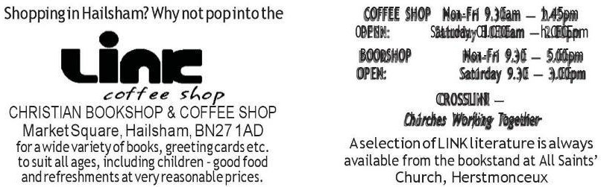

Herstmonceux Free Church News
Sunday 3rd October 10am – 12 midday

First Sunday at the Village Hall We warmly welcome everyone to join us for our first breakfast event this year. Come for a chat. Catch up with old friends or make new ones and enjoy a relaxed buffet style, free breakfast or simply a cup of tea or coffee. (No service at the Free Church)

Services at Herstmonceux Free Church in October

3rd NO SERVICE AT THE CHURCH - first Sunday in the month (see above).
17th October 10.45am, Harvest Service. Please do join us for our harvest
celebration.
10th, 24th, 31st, Sunday morning 10.45am
.

For further information see our website: www.herstmonceuxfreechurch.org.uk or contact our Family and Community Worker, Sylvia Catt 07909 644762.

RELIGIOUS SOCIETY OF FRIENDS (QUAKERS) HERSTMONCEUX LOCAL MEETING
We meet at 10.45 on the first and third Sunday of every month. Join us for a quiet hour of worship and reflection at the Friends’ Meeting House, West End, Herstmonceux BN27 4NR or call 01323 844269 for more details. www.quaker.org.uk

HAILSHAM and POLEGATE CATHOLIC CHURCHES
Sunday Masses
Sunday 10:30am at St. Wilfrid’s Hailsham Sunday 9:00am, at St. George’s Polegate
Holy Days
10:00am at St. George’s, Polegate; 7:00pm at St. Wilfrid’s, Hailsham

Would you like your business to reach more of the Herstmonceux and Wartling community?
Advertising in the Herstmonceux and Wartling Parish News for the year (12 editions) ranges from £40 to £125 depending on the size of the advert.
Contact Sarah Honeysett, via email on hwparishnews@outlook.com
PARISH NEWS
Please send text copy email (together with your name and phone number) to Miss Katherine Blake, theparishnews@hotmail.com (c/o Parish News). Deadline is midday on the 15th of the month prior to publication.
N.B. due to new arrangements no copy can be accepted later.
PARISH NEWS SUBSCRIPTIONS
If you would like a copy of the Parish News delivered to your door each month for the discounted rate of £5:50 for the year, then please contact Chris Edwards on 01323 833207 or email hwparishnews_subscriptions@hotmail.com

All SAints’, Herstmonceux
St. MAry MAgdAlene, WArtling

www.herstmonceuxandwartlingchurches.com

PRIEST-IN-CHARGE Rev. Richard Steven Tel: 01323 833124
ASSISTANT PRIEST Rev. Peter Doodes Tel: 01424 892329
LAY READER Mr. John King, Camelot, Boreham Street
Tel: 832997
CHURCHWARDENS
Herstmonceux Mrs. Pam Kendall Tel: 833079
Wartling Mr. David Harding Tel: 832150 Mr. Paul Hurle Tel: 832980
ASSISTANT CHURCHWARDENS

Herstmonceux | Mr. Mick Bridges | Tel: 833831
PCC SECRETARIES
Herstmonceux | Mrs. Melinda Stone | Tel: 833976
Wartling | Mrs. Penny Vasey | Tel: 833603
PCC TREASURER for both Herstmonceux and Wartling
 | Mr. Andrew Phillips | Tel: 832619
ORGANISTS
Herstmonceux | Mrs. Anne Kenward | Tel: 441244
Wartling | Mr. David Oakenfold | Tel: 724676
VERGERS
Herstmonceux | Mrs. Pam Kendall | Tel: 833079
Wartling | Mr. Paul Hurle | Tel: 832980
FRIENDS OF ALL SAINTS’
Treasurer Mr. Tim Roberts Tel: 832400
GIFT AID SECRETARY for Herstmonceux and Wartling

Mr. Andrew Phillips Tel: 832619

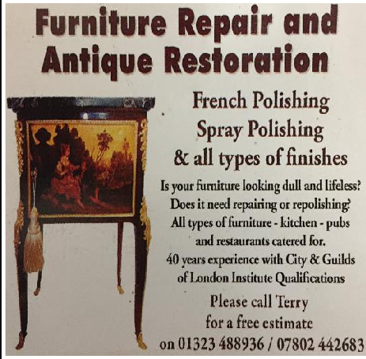

Would you like your business to reach more of the Herstmonceux and Wartling community?
Advertising in the Herstmonceux and Wartling Parish News for the year (12 editions) ranges from £40 to £125 depending on the size of the advert.
Contact Sarah Honeysett, via email on hwparishnews@outlook.com

Tel: 01323 831555 Follow us on Facebook and instagram

